**Leadership Competencies Checklist**



**INSTRUCTIONS**

1. Reflect honestly on your own leadership behaviors and mark the competencies you actively demonstrate.
2. Identify areas where you can strengthen or further develop your leadership competencies.
3. Review the checklist with your manager or coach as part of your development plan.

|  |  |  |  |  |  |  |
| --- | --- | --- | --- | --- | --- | --- |
| **Competency** |  | | **Actions to take** | | **Helpful resources** | |
| **Social Intelligence (SI)** |  | * Practice active listening to understand others’ perspectives. * Engage in diverse social situations to broaden understanding of social cues and dynamics. | | **Book:** “Social Intelligence: The New Science of Success” by Karl Albrecht | |
| **Problem-solving** |  | * Tackle challenges using structured frameworks like the “5 Whys”. * Regularly brainstorm hypothetical solutions to enhance creative thinking. | | **Article*:*** “[9 Problem-Solving Strategies for Managers](https://bigpicture.one/blog/problem-solving-strategies/)” by BigPicture | |
| **Change management** |  | * Volunteer for projects requiring adaptation to change**.** * Learn and apply change management models (e.g., Kotter’s 8-Step Change Model). | | **Article***:* “[HR & Change Management: Beyond the Kotter Model](https://www.aihr.com/blog/hr-change-management/)” by David Creelman for AIHR | |
| **Innovation** |  | * Dedicate time weekly to explore new ideas/technologies. * Encourage and join in judgment-free brainstorming sessions. | | **Podcast***:* “[How the Best Leaders Drive Innovation](https://open.spotify.com/episode/2p6RNZWIHt5Czdt5gmUCVB)” by HBR On Leadership | |
| **Interpersonal skills** |  | * Practice clear, concise communication (written and verbal). * Seek feedback on your communication style and areas to improve. | | **Article***:* “[5 Ways To Improve Your Communication Skills as a Leader](https://www.forbes.com/sites/rachelwells/2023/12/04/5-ways-to-improve-your-communication-skills-as-a-leader/)” by Forbes | |
| **Emotional Intelligence (EI)** |  | * Reflect on emotional reactions to identify patterns. * Practice empathy by seeing situations from others’ perspectives. | | **Book***:* “Emotional Intelligence 2.0” by Travis Bradberry & Jean Greaves | |
| **Coaching ability & trustworthiness** |  | * Offer peers constructive feedback in a supportive way. * Be consistent in your actions and follow through on promises. | | **Article***:* “[The Leader as Coach](https://hbr.org/2019/11/the-leader-as-coach)” by Harvard Business Review | |

|  |  |  |  |
| --- | --- | --- | --- |
| **Competency** |  | **Actions to take** | **Helpful resources** |
| **(Learning) Agility** |  | * Take on tasks outside your comfort zone. * Reflect on your learning experiences (what worked, what didn’t). | **Article***:* “[Learning Agility: What HR Professionals Need to Know](https://www.aihr.com/blog/learning-agility/)” by AIHR |
| **Managing yourself** |  | * Set achievable goals and monitor progress. * Develop effective time management strategies (e.g., Pomodoro Technique). | **Article***:* “[18 Effective Time Management Strategies and Techniques](https://www.upwork.com/resources/time-management-strategies)” by Upwork |
| Courage |  | * Take small risks daily to build confidence in facing fears. * Speak up about ideas and opinions, even when uncomfortable. | **Podcast*:*** “Dare to Lead” by Brené Brown |
| Conflict management |  | * Approach conflict with curiosity rather than judgment - ask clarifying questions * Use the SBI model (Situation-Behavior-Impact) to frame feedback constructively | **Article**: “[11 Practical HR Conflict Resolution Examples On Managing Workplace Conflict](https://www.aihr.com/blog/hr-conflict-resolution-examples/)” by AIHR |
| Decision-making |  | * Use a structured framework like a decision matrix for your next big choice * Before deciding, ask: “What’s the risk of doing nothing?” | **Article**: “[Free Decision Matrix Template: Plus Steps To Effectively Use It in Decision-Making](https://www.aihr.com/blog/decision-matrix-template/)” by AIHR |
| Setting and sharing a compelling vision |  | * Craft a 1-2 sentence version of your team’s vision and share it in your next team meeting * Highlight how current priorities connect to long-term goals | **Book***:* “Start with WHY” by Simon Sinek |
| Entrepreneurship |  | * Identify one process you could improve or streamline this month * Pitch a small-scale experiment to test a new idea | **Podcast*:*** “[Masters of Scale](https://mastersofscale.com/)” by Reid Hoffman |
| Inclusiveness |  | * Create space for quieter voices by offering optional follow-ups, like shared docs or 1:1 chats, to gather input from those who haven’t spoken up * Review your team practices for hidden biases or exclusion (e.g., meeting times, feedback style) | **Book***:* “The Culture Map” by Erin Meyer |



aihr.com

|  |  |  |  |
| --- | --- | --- | --- |
| Co Competency |  | **Actions to take** | **Helpful resources** |
| People management |  | * Set a 1:1 goal with each team member this month based on their career interests * Give feedback regularly, both developmental and appreciative | **Book***:* “The Radical Candor” by Kim Scott |
| Industry knowledge and expertise |  | * Subscribe to one trade publication or analyst newsletter relevant to your sector * Schedule time each week to review trends that could impact your workforce | **Newsletter: “**[Leading HR](https://www.aihr.com/leading-hr/)” by AIHR |
| Organizational citizenship behavior |  | * Volunteer to support a cross-team effort that isn’t in your job description * Publicly recognize a colleague for their behind-the-scenes contributions | **Article**: “[The Power of Small Wins](https://hbr.org/2011/05/the-power-of-small-wins)” by Harvard Business Review |



aihr.com

[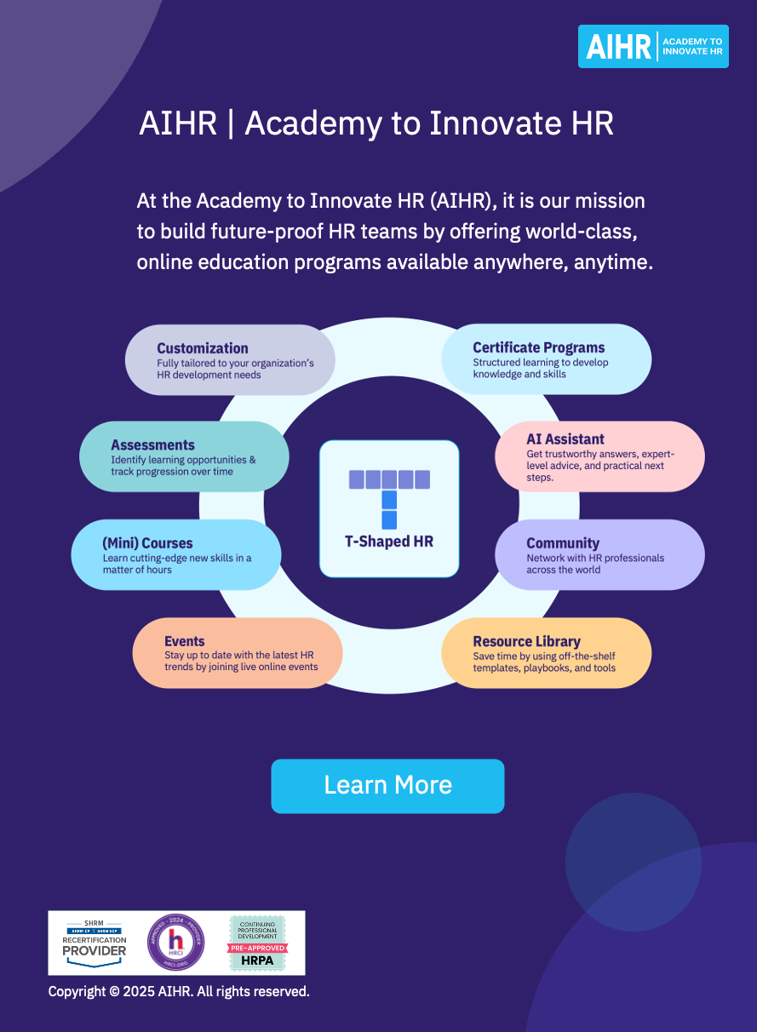](https://www.aihr.com/business/?utm_source=resource&utm_medium=resource&utm_campaign=templates&utm_content=templates)